**Volunteer Recruitment Pack**

April 2025

**Bishopton Community Centre CIO is a registered Charity**

**Number 1188894**

**Welcome**

Welcome to Bishopton Community Centre’s Volunteer Recruitment pack. We are looking for more volunteers with the right skills to join our friendly community centre.

**Background to Bishopton Community Centre**

Bishopton Community Centre is a charity which runs a community centre for residents in Bishopton, Stratford Upon Avon.

Traditionally we have been a versatile community space for groups and societies to hire. However, in the last few years we have tried to do more local community activities such as our weekly Warm Hub, Therapy session and our new Community Garden.

The centre is entirely run by volunteers, who work tirelessly to ensure that it remains an accessible and inclusive space for everyone.

Activities at the Centre include:

* Jubilee Club
* Dance classes
* Tai Chi
* Table Tennis
* Church services
* Dementia café
* Brownies and guides
* Stratford Foodbank
* Pilates

Our facilities include.

* On Site Parking in Bishopton Primary School car park
* Accessible Toilet
* Baby Changing facilities
* Toilets
* Small kitchen with crockery and dishwasher, microwave and fridge
* 7 large tables
* 60 Chairs
* Free Wi-Fi for users
* Large TV (for viewing of own content, no viewing of live TV)
* Table tennis table and equipment
* Storage negotiable for long term hirers

**Welcome form Penny Keynton Hook Chair of Trustees**

Thank you for your interest in becoming a volunteer for Bishopton Community Centre.

Bishopton Community Centre is a much-needed community space and hub just by the side of Bishopton Primary School. We have been providing a community space for over 30 years. Yet in recent years we have wanted to do more for the very community all the Trustees and volunteers live in. In cooperation with a new community development worker (The lovely Abi: Community Builder) we have started a social community warm hub where people can come to chat, have a cup of tea, a piece of cake and access information on a variety of services available to them.

We have also made great strides in recent years in securing funding from Stratford District Council, National Government, Warwickshire County Council and Stratford Town Trust for new kitchen equipment, the creation of a new Garden space to replace waste ground at the back of the Centre, new toilets and a new electronic front door to accommodate users who have mobility issues.

However, we want to do more and need new volunteer to bring their skills, expertise and knowledge to further strengthen what we do as we work to grow and have even more of an impact on the community.

To this end we are particularly keen to hear from people who have skills, knowledge and experience in:

* Health and safety
* Marketing and communications
* Business planning
* Finance/accounts
* Facility operations

Previous volunteer experience is not necessary, and we welcome applications from all ages and backgrounds.

There is no personal liability as a volunteer so long as your actions are legal and not significantly negligible.

Becoming a volunteer will give you a wide variety of benefits such as:

**1. Give something back**

Becoming a volunteer is a fantastic way to give something back to a cause or community you care about. You will be playing an integral part in the way the charity is run, ensuring it remains sustainable and financially viable. The help you provide will be invaluable.

**2. Meet new people**

Joining a new organisation or charity is a fantastic way to meet new people from a range of different personal and professional backgrounds. There will be events or activities to do within your local community, as well as many other opportunities to meet new and interesting people.

**3. Learn new things**

Getting involved as a charity volunteer is a great way to put your skills to use but can also be a fantastic opportunity to learn new things. You’ll get great insight into what’s involved in a community centre and gain skills.

**4. Improve your CV and enhance your professional development**

Being a Charity volunteer is great to enhance your CV or act as stepping stone back into work or keep active after retirement. Young people or people looking for work are increasingly being encouraged to get involved as volunteers due to the fantastic opportunity it provides for professional development.

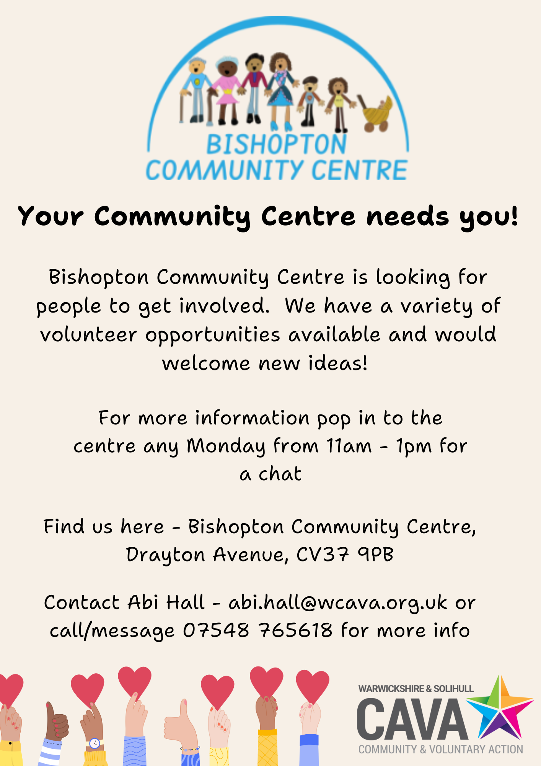**Bishopton Community Centre**

**Volunteer Role description**

**Voluntary role title:** Marketing & Communications Volunteer

*The volunteer is a member of the Bishopton Community Centre team, performing tasks within his/her abilities and is not used to replace staff.*

**Responsible to:** *Bishopton Community Centre Charity Trustees*

**Day/hours:** Flexible hours to be agreed and able to work from home

## **Role Summary**

To assist *Bishopton Community Centre* in promoting its activities, events and room hire through a variety of different mediums, including updating the website, poster/flyer creation and distribution and social media posts. A minimum commitment of six months is required.

Sharing this role with another volunteer is possible.

**Benefits to the Volunteer**

The role would suit a person looking to gain experience in marketing in the not-for profit sector, and/or someone seeking work experience before returning to work after a career break.  
The role would provide opportunities to get involved in varied and interesting aspects of marketing and promotion of the charity, including website administration, volunteer recruitment, designing promotional content, raising the profile of the centre and increasing engagement, event planning and social media management and working with the trustees of the community centre.

## **Specific Duties**

1. Identifying new avenues to promote *Bishopton Community Centre* to the local community*,* promotingits activities andgenerating new room bookings.
2. Keeping the web site and social media pages up to date
3. Designing and producing promotional material
4. Uploading volunteer role information to an online volunteer recruitment website.
5. Designing and creating wording and images for recruitment posters and flyers.
6. Take part in activities/events/meetings when appropriate.
7. Bring to the attention of *Bishopton Community Centre* areas of concern relating to its work.

Please note that this task description is intended as a guide only. You may be asked to do other reasonable tasks, in agreement with yourself, if time allows.

**Skills needed**

Marketing experience, both online and offline. Desirable but willingness to learn just as important

Good IT skills with the ability to confidently produce marketing materials such as posters, as well as forms and monitoring documents and the ability to create engaging website content with regular updates.

Confident verbal and written communication with attention to detail.

Familiarity with social media platforms and the ability to create and upload engaging content.

Some understanding of the voluntary sector and the needs of communities.

**All volunteers are expected to adhere to Bishopton Community Centre policies and procedures**

**Bishopton Community Centre**

**Volunteer role description**

**Voluntary role title:** Health & Safety Volunteer

*The volunteer is a member of the Bishopton Community Centre team, performing tasks within his/her abilities and is not used to replace staff.*

**Responsible to:** *Bishopton Community Centre Trustees*

**Day/hours:** Flexible hours to be agreed. Working from home and/or role sharing is also possible.

## **Role Summary**

To assist *Bishopton Community Centre* in ensuring their Health & Safety policy and procedures are up-to-date and are followed. Ensuring Risk Assessments are up-to-date and are followed by all users of the centre. A minimum commitment of six months is required.

Sharing this role with another volunteer is possible.

**Benefits to the Volunteer**

The role would suit a person with an interest and background in Health & Safety who would like to give something back to the community. This would suit someone looking to gain experience in the not-for-profit sector, and/or someone seeking work experience before returning to work after a career break. The role would provide opportunities to get involved in all aspects of developing the charity and supporting the trustees.

## **Specific Duties**

1) Checking, reviewing, developing and updating Health & Safety procedures in relation to the Community Centre and its activities to ensure that all users of the Centre are kept safe from harm, and are aware of what the procedures are for using/hiring the centre and that these are adhered to.

2) Checking, reviewing and updating Risk Assessments in relation to all activities to ensure that all users of the Centre are kept safe from harm, and are aware of potential risks and how to mitigate these risks. Ensure users/hirers of the centre undertake risk assessments where necessary.

3) Ensuring that the centre is accessible to all users.

4) Promote a positive health and safety culture in the centre.

5) Keeping records of incidents, accidents and near misses, ensuring that trustees are aware of these, and any adjustments are made to prevent similar incidents happening in future.

6) Deliver H&S induction training to new volunteers.

7) Act as a point of reference for any questions regarding Health and Safety.

8) Providing Health & Safety reports to the Board of Trustees on a quarterly basis and making recommendations as necessary.

Please note that this task description is intended as a guide only. You may be asked to do other reasonable tasks, in agreement with yourself, if time allows.

**Skills Needed**

An understanding of Health & Safety regulations. (A Health & Safety qualification would be desirable).

Previous experience of working in a Health & Safety role.

A confident communicator (written, verbal & IT) who can convey information to others in simple terms and can update documents as required.

A calm, practical approach to Health & Safety matters.

A team player who can support the trustees.

Some understanding of the voluntary sector and the needs of communities.

**All volunteers are expected to adhere to Bishopton Community Centre policies and procedures**

**Bishopton Community Centre**

**Volunteer role description**

**Voluntary role title:** Finance Volunteer

*The volunteer is a member of the Bishopton Community Centre team, performing tasks within his/her abilities and is not used to replace staff.*

**Responsible to:** *Bishopton Community Centre Treasurer Trustee*

**Day/hours:** Flexible hours to be agreed. Working from home and/or role sharing is also possible.

## **Role Summary**

To assist *Bishopton Community Centre* in ensuring financial procedures are up-to-date and are followed by all users of the centre. To keep a record of all financial transactions in and out of the Community Centre bank account. A minimum commitment of six months is required.

Sharing this role with another volunteer is possible.

**Benefits to the Volunteer**

The role would suit a person with an interest and background in accountancy, bookkeeping or finance who would like to give something back to the community. Someone looking to gain experience in the not-for-profit sector, and/or someone seeking work experience before returning to work after a career break.   
The role would provide opportunities to get involved in all aspects of developing the charity and supporting the trustees to provide activities and events for the local community.

## **Specific Duties**

1) Checking, reviewing, developing and updating the financial procedures in relation to the Community Centre and its activities, with support from the Trustees.

2) Ensuring that all monies paid in and out of the Centre’s bank accounts are documented appropriately.

3) Assist in managing the accounts of the Community Centre and produce financial reports and financial breakdowns for all trustee meetings on the financial health of the Community Centre.

4) Monitor the budgets and reserves to ensure the Community Centre has a stable financial position.

5) Ensure the Community Centre complies with legal requirements and financial regulations.

6) Act as a point of reference for any questions regarding financial matters and queries.

7) Filing invoices and receipts.

8) Monitoring the accounts for any anomalies and reporting any issues to the Trustees.

Please note that this task description is intended as a guide only. You may be asked to do other reasonable tasks, in agreement with yourself, if time allows.

**Skills Needed**

Experience of dealing with financial tasks and producing financial reports within a business/charity setting.

An experienced, detail focused finance person who can use online banking and accounting packages.

Strong verbal, written and IT skills and the ability to present and explain financial information in a clear, concise way.

A team player who can support the trustees.

Some understanding of the voluntary sector and the needs of communities.

Financial qualifications would be desirable.

**All volunteers are expected to adhere to Bishopton Community Centre policies and procedures**

**Volunteer role description**

**Voluntary role title:** Business Planning Volunteer

*The volunteer is a member of the Bishopton Community Centre team, performing tasks within his/her abilities and is not used to replace staff.*

**Responsible to:** *Bishopton Community Centre Chair of Trustees*

**Day/hours:** Flexible hours to be agreed. Working from home and/or role sharing is also possible.

## **Role Summary**

To assist *Bishopton Community Centre* in ensuring all procedures are up-to-date and are followed by all users of the Centre. To have an overview of all aspects of the running of the Community Centre and to assist the trustees to formulate a strategic business plan to take the Centre forward. To raise the profile of the Centre and promote it widely within Stratford Upon Avon. To form and promote relationships with other local organisations (schools, businesses, voluntary organisations etc). To gather information from the local area and residents on what people want from the Centre.

A minimum commitment of six months is required.

Sharing this role with another volunteer is possible.

**Benefits to the Volunteer**

The role would suit a person with an interest and background in running a not-for-profit community centre who would like to be involved in a community project and give something back to the community. Someone looking to gain experience in the not-for-profit sector, and/or someone seeking work experience before returning to work after a career break.   
The role would provide opportunities to get involved in all aspects of developing the charity and supporting the trustees to provide activities and events for the local community.

## **Specific Duties**

1) Checking, reviewing, developing and updating the procedures in relation to the overall running of Community Centre and its activities, with support from the Trustees.

2) To have an overview of all aspects of the running of the Community Centre and to assist the trustees to formulate a 3-year strategic business plan to take the Centre forward and ensure sustainability.

3) To support the Marketing & Communications Volunteer to raise the profile of the Centre and its activities and promote it widely within Stratford Upon Avon.

4) To form and promote relationships with other local organisations (schools, businesses, voluntary organisations etc) to work in partnership for the benefit of the local community.

5) Supporting the Treasurer and Finance Volunteer by having an overview to ensure the Community Centre complies with legal requirements and financial regulations.

6) To gather information from the local area and residents on what people want from the Centre to develop new services and activities with the Trustees, and to identify potential funders for these projects.

7) To write a strategic business plan and ensure that the Centre has a clear purpose, vision, aims and objectives and that these are followed, with support from the Trustees, Finance Volunteer and Marketing & Communications Volunteer.

8) To identify risks and opportunities and support the Trustees to manage these.

Please note that this task description is intended as a guide only. You may be asked to do other reasonable tasks, in agreement with yourself, if time allows.

**Skills Needed**

Experience of business planning, preferably in a voluntary sector setting.

Strong verbal, written and IT skills and the ability to produce clear, concise documents.

A team player who can support the trustees, volunteers and anyone using the Community Centre.

The ability to build rapport with members of the public, local businesses and stakeholders and collect information on wants and needs.

Collaboration & problem solving.

An understanding of the voluntary sector and the needs of communities.

**All volunteers are expected to adhere to Bishopton Community Centre policies and procedures**

**Volunteer Application Form**

|  |  |
| --- | --- |
| **Contact Details** | |
| Name |  |
| Address |  |
| Postcode |  |
| Phone No(s) |  |
| Email Address |  |

|  |
| --- |
| **Do we need to make any disability-related adjustments to allow you to take part in the recruitment process? Yes/no** |
| If Yes: |

|  |  |
| --- | --- |
| **References**  **Please give us contact details of two referees (these will only be contacted if your application is successful)** | |
| Work reference current/most recent:  Post code:  Telephone:  Email: | Reference:  Post code:  Telephone:  Email: |

|  |
| --- |
| **Please state briefly any skills and experience that you feel you could bring to your role as a Bishopton Community Centre volunteer?** |
|  |

|  |
| --- |
| **Skills**  **We value the many skills and experience that people can bring to the centre, including skills developed through employment, volunteering, managing a home, raising children, study etc. Please indicate whether you have any skills and experience in the following areas:** |
| o Health and safety  o Marketing  o Financial  o Fundraising  o Business Planning  o Social media  o Strategic Planning  o Managing a facility  o  o Other (please specify) …………………………………………………………………………………………. |

|  |
| --- |
| **Privacy notice:**  We process personal data relating to those who apply for volunteer vacancies with us or who send speculative job applications to us. We do this for volunteer purposes, to assist us in the selection of candidates for volunteering and to assist in the running of the business. The personal data may include identifiers such as name, date of birth, personal characteristics such as gender, qualifications and previous employment history.  We will not share any identifiable information about you with third parties without your consent unless the law allows or requires us to do so. The personal data provided during an application process will be retained for a period of at least six months or, if required by law, for as long as is required.  This privacy notice does not form part of a volunteer offer or contract between us. If we make a volunteer offer to you, we will provide further information about our handling of your personal information in a volunteer context separately.  If you would like to find out more about our data retention policy and how we use your personal data, you want to see a copy of the information about you that we hold or have any questions or issues regarding data protection, please email us with the Subject “Data Protection Request”. |
| **Where did you hear about us:** |

|  |
| --- |
| **Declaration**  The above information is true. I understand that any volunteer offer made based on untrue or misleading information may be withdrawn or my volunteer role terminated.  **Signed: Date:** |

**Additional Information**

***Time commitment***

Information on the expected time commitment is available on the role descriptions. Please come back if you are seeking more flexibility.

***Conflict of interest***

All candidates will be asked to disclose any actual, potential or perceived conflict of interest, and these will be discussed with the candidate to establish whether and what action is needed to avoid a conflict or the perception of a conflict.

**Can I volunteer if I claim benefits?**

In most cases, there is no limit, as long as:

* The only money you get from volunteering is to cover expenses, such as travel costs.
* You continue to meet the conditions of the benefit you get.

For more information see: [**www.gov.uk/volunteering/when-you-can-volunteer**](http://www.gov.uk/volunteering/when-you-can-volunteer)

**How to apply**

If you would like to discuss a volunteer role before you apply, please contact Abi Hall, Community Builder on 07548 765618 or email [abi.hall@wcava.org.uk](mailto:abi.hall@wcava.org.uk)

Feel free to pop into our Monday Social for a chat and a cuppa. This is every Monday apart from Bank Holidays 11am to 1pm at the Centre

Once you have decided to apply, please email a completed application form to Penny at [pkh1bcc@gmail.com](mailto:pkh1bcc@gmail.com) and she will get back in touch.